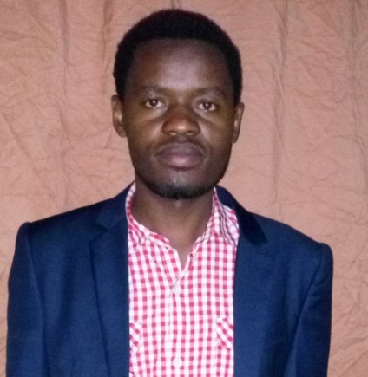
Curriculum Vitae (CV)

Names: Joseph NZAYISENGA

Tel: (250)0788265786/0722265686

E-mail: njeph2010@gmail.com

Personal detail

ID number: 1198880095309069
Date of birth: 01 January 1988
Province: Western
District: Rutsiro
Sector: Boneza
Cell: Kabihogo
Village: Kamuyaga
Residence: Muhanga/Gitarama
Sex: Male
Status: Single
Nationality: Rwandese
Languages: English, French and Kinyarwanda

Key Skills
I hold Bpharm (Bachelor in Pharmacy) from UR (University of Rwanda) and I am registered pharmacist in our country , I have motivation, organization and leadership attitudes. I have excellent verbal and written communication skills In Kinyarwanda, French and English. Also computer skills in Microsoft (word, excel, power point, publisher, access), SPSS 16, Epidata and in use of web browsers and Internet.

Educational Background
School/College | position | Subjects | Degree/Grade | Date of completion
UR (University of Rwanda) | Bachelor | Pharmacy | BPHARM (A0) | 2011-2015
HARVARD UNIVERSITY through edX. | Online learning | PH201x: Health and Society | CERTIFICATE | 2013- 2014
THE UNIVERSITY OF TEXAS through edX. | Online learning | 4.01x: The Impact of Drug Development | CERTIFICATE | 2013
HARVARD UNIVERSITY through edX. | Online learning | HSPH-HMS214x: Fundamentals of Clinical Trials | CERTIFICATE | 2013- 2014
College S^{t} Mathieu | A level | MCB (Math, Biology, chemistry) and GP | A2  49/55 | 2007-2009
E.S. APAKAPE | Ordinal level | Math, Physics, Biology, Chemistry, History, Geography, French, English, Kinyarwanda. | 5.2/11 | 2003-2006
E.P.KARUGALIKA | Primary school | STE, Geography, Math, French, English, Kinyarwanda. | 54.5% | 1995-2003
Vocational Training and symposium:
Year | Training | organizer
20th November 2009 to 15th December 2009 | Intore | Commission of unity and reconciliation through Itorero
26th March 2011 | Interviewing skills for health professionals | RPSA
March 2011-Nov 2011 | Civic education | NUR Former and Huye District
April 05th, 2014 | Enhancing Medication use safety and patient care through pharmacy practice | RPSA (Rwanda Pharmaceutical Student’s Association)
7th to11th July 2014 | Entrepreneurship or Enterprise Rwanda | AIP (Africa innovation prize)
21st February 2015 | Integrating emerging technologies for the improvement of health care delivery | RPSA

Relevant experience
Annual Physical inventory 2014-2015 at CHUB HOSPITAL in pharmacy department, we collected data of commodity health then we entered data of health commodity in MS excel, analyzed and we made an observation then finally we wrote Report. We worked as independent team. I have Experience of one year of working in community pharmacy as responsible pharmacist.
Languages
Language | Speaking | Writing
English | Excellent | Excellent
French | Very Good | Excellent
Kinyarwanda | Excellent | Excellent
Kiswahili | Good | Good

Work experience
Annual pharmacy Physical inventory 2014-2015 and processing at CHUB, President of comminoute ecclesial de base (CEB) in our class (January/2011-2015), I worked in update Rwanda national electoral list update in 2010 as volunteer. I'm pharmacist responsible at ALANIC Pharmacy from November 2015 up to present. I worked at Alanic Pharmacy Ltd from 15th November2015 to 30th September 2016. I work at Kindness Pharmacy from 1st November, 2016 up to present. Also I work at Rwanda Community Pharmacists Union (RCPU) in office of Research and Education from July to present.

Computer skills
Use and installation of: Microsoft (word, excel, power point, publisher, access), Adobe Photoshop, Window 7 and 8 Installation, Epidata, SPSS, networking (Facebook, Twitter, LinkedIn, WordPress, blogspot, kype, email, instagram, wattage and edx).

References people
NDIKURYAYO Athanase (Phn) Tel: +250783272900
BADARA Leonidas (lawyer) Tel: +250788736328
Dr NKERAMIHIGO Emmanuel (Lecturer) Tel: +250788555273

I hereby, declare that the information given above is true and correct to the best of my knowledge.

Phn Joseph NZAYISENGA.

